A FIELD PROJECT REPORT

on

**“Skin Cancer Detection Using CNN Algorithm”**

**Submitted by**

221FA04307- Sai Ragini

221FA04355- Dedeep teja

221fa04376 - Sohail

221FA04409- Praveen

Under the guidance of

*Dr.Deva Kumar*

*Designation*



**Department of Computer Science & Engineering**

**VIGNAN'S FOUNDATION FOR SCIENCE TECHNOLOGY AND RESEARCH Deemed to be UNIVERSITY**

**Vadlamudi, Guntur.**

**ANDHRA PRADESH, INDIA, PIN-522213**



CERTIFICATE

This is to certify that the Field Project entitled “Skin Cancer Detection Using CNN Algorithm” being submitted by 221fa04307(Ragini), 221fa04355(Dedeep teja), 221fa04376(Sohail), 221fa04409(Praveen) for partial fulfilment of Field Project is a bonafide work carried out under the supervision of Assistant Professor, Department of CSE.

|  |  |  |
| --- | --- | --- |
| Guide name& Signature |  | Dr.K.V.Krishna Kishore |
| Assistant/Associate/Professor, CSE | HOD,CSE | Dean, SoCI |



DECLARATION

We hereby declare that the Field Project entitled “Skin Cancer Detection Using CNN Algorithm is being submitted by 221FA04307(Ragini), 221FA04355(Dedeep teja), 221FA04376(Sohail), 221fa04409(Praveen) in partial fulfilment of Field Project course work. This is our original work, and this project has not formed the basis for the award of any degree. We have worked under the supervision of ., Assistant Professor, Department of CSE.

BY

**221FA04307-Sai Ragini**

**221FA04355-Dedeep teja**

**221FA04376-Sohail**

**221FA04409-Praveen**

Date:

|  |
| --- |
| ABSTRACT This project explores the application of Convolutional Neural Networks (CNN) in detecting and classifying skin cancer types from dermatoscopic images. Leveraging a large dataset, including categories such as melanoma, basal cell carcinoma, and benign nevi, the model aims to assist dermatologists by providing rapid, reliable diagnostic support. Key steps included data pre-processing with normalization and augmentation to address class imbalance, followed by model training using a custom CNN architecture optimized with transfer learning. The model’s performance was evaluated using accuracy, F1-score, and AUC-ROC metrics, achieving high accuracy and recall rates, particularly in detecting melanoma. These results underline the potential of CNN models in enhancing early detection of skin cancer, with future work focusing on deploying the model in real-world clinical applications and improving interpretability through visualizations.  **TABLE OF CONTENTS**  1.**Introduction**  1.1 Problem Definition  1.2 Project Overview  **2.Literature Survey**    **3.METHODOLOGY**  3.1 Data Collection  3.2 Data Analysis  3.3 Data Cleaning  3.4 Data Preprocessing  3.5 Testing and Training  3.6 Model Evalutation  **4.Results and Discussion**  **5.Conclusion** |

**INTRODUCTION**

#### 1.1 Problem Definition

Skin cancer is one of the most prevalent forms of cancer worldwide, and its early detection is crucial for successful treatment. Traditional methods of diagnosis often involve visual inspections and biopsies, which can be time-consuming and prone to human error. To enhance the accuracy and speed of skin cancer detection, a computer-aided diagnosis system using Convolutional Neural Networks (CNNs) can be employed to analyze skin lesion images and identify potential cases of melanoma and other types of skin cancer.

#### 1.2 Project Overview

This project aims to develop an automated skin cancer detection system using deep learning techniques, specifically Convolutional Neural Networks (CNN). The CNN model will be trained on a dataset of dermoscopic images to classify whether a skin lesion is benign or malignant. The system will process and analyze image features such as texture, shape, and color, which are vital in distinguishing between cancerous and non-cancerous skin lesions. The project will involve data preprocessing, model training, and performance evaluation.

**LITERATURE SURVEY**

Convolutional Neural Networks (CNNs) have become a cornerstone in machine learning, particularly for tasks involving image recognition and classification. Over the years, they have proven to be highly effective in medical image analysis, including skin cancer detection. Esteva et al. (2017) demonstrated that CNNs trained on large datasets of dermoscopic images could classify skin lesions with dermatologist-level accuracy. This study, among others, has shown that CNNs can automatically learn and extract features such as texture, shape, and color, which are critical for distinguishing between benign and malignant lesions. Moreover, the development of deep learning architectures like ResNet (He et al., 2016) and VGGNet (Simonyan & Zisserman, 2014) has allowed for the creation of models that can go deeper without encountering issues like vanishing gradients, thereby improving classification accuracy.

Transfer learning has also played a pivotal role in CNN-based skin cancer detection. By using models pre-trained on large datasets such as ImageNet, researchers can fine-tune these models on smaller, domain-specific datasets, thus improving performance with less computational effort. Yosinski et al. (2014) showed that transfer learning enables CNNs to be adapted across different tasks, including medical image classification. In cases where datasets are limited, techniques like data augmentation (Tschandl et al., 2019) are often employed to synthetically expand the training set, improving the model’s ability to generalize.

Despite these advancements, challenges remain. One major issue is the interpretability of CNN models, which are often criticized as "black boxes" due to their complexity. Methods such as heatmaps and saliency maps are now being used to provide more transparency into CNN decision-making processes, especially in sensitive areas like healthcare (Zeiler & Fergus, 2014). Additionally, the imbalance in datasets—where benign cases far outnumber malignant ones—can lead to biased models that underperform in detecting critical cancer cases (Brinker et al., 2019). Researchers are continuously working on improving model generalization, particularly through innovations in explainable AI and the integration of multimodal data, ensuring that CNNs become more reliable tools in early skin cancer detection.

The application of CNNs in skin cancer detection has evolved from basic image classification models to sophisticated systems that incorporate transfer learning, data augmentation, and explainability features. While CNNs have shown impressive results, ongoing research is focused on overcoming challenges such as data scarcity, class imbalance, and model interpretability to ensure that these models can be effectively deployed in real-world clinical settings. With the growing availability of large, annotated datasets and the advancement of deep learning techniques, CNN-based models are expected to play an increasingly important role in early skin cancer diagnosis and treatment planning.

**Methodology**

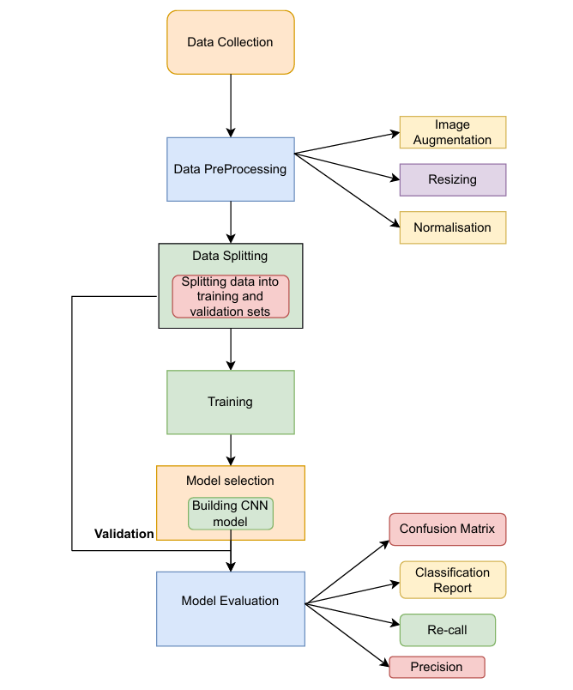

1. **Data Collection :**

Objective : Gather a comprehensive image dataset for accurate skin cancer detection.

**Steps:**

Dataset Acquisition: Identify and obtain a reliable dataset (e.g., the HAM10000 dataset) that includes labeled images of various skin conditions.

Extraction : Extract the contents of the zip file using appropriate tools or programming libraries (e.g., Python’s `zipfile`).

Loading Data: Use libraries like `PIL` or `OpenCV` to load images into a structured format (like NumPy arrays or Pandas DataFrames) for subsequent processing.

**2. Data Preprocessing:**

Objective: Enhance image quality and standardize the dataset to improve model accuracy.

**Steps:**

Image Augmentation: Implement a variety of augmentation techniques, such as:

Rotation: Rotate images by random degrees to increase rotational invariance.

Flipping : Horizontally flip images to enhance dataset diversity.

Zooming : Randomly zoom in/out to simulate different viewing conditions.

Brightness Adjustment: Alter brightness levels to make the model robust against lighting conditions.

Resizing: Resize all images to a fixed size (e.g., 224x224 pixels) to ensure uniform input for the CNN.

Normalization: Normalize pixel values to [0, 1] or standardize by subtracting the mean and dividing by the standard deviation to speed up convergence during training.

**3. Data Splitting:**

Objective: Ensure a robust evaluation of the model by splitting the dataset effectively.

**Steps:**

Stratified Splitting: Use stratified sampling to maintain the ratio of healthy to unhealthy images in both the training and validation sets.

Implementation: Employ tools like `train_test_split` from `scikit-learn` to automate the splitting process and facilitate reproducibility.

**4. Model Selection :**

Objective: Design a suitable CNN architecture tailored for the nuances of skin cancer detection.

**Steps:**

Layer Configuration: Define the architecture by layering:

Convolutional Layers: Apply multiple convolutional layers to extract features, with increasing depth to capture complex patterns.

Pooling Layers: Integrate max pooling layers to reduce dimensionality and computational load, preserving essential features.

Fully Connected Layers: Create fully connected layers at the end to interpret the features and classify images.

Hyperparameter Tuning: Experiment with different architectures (e.g., VGG16, ResNet, EfficientNet) and optimize hyperparameters like:

Learning Rate: Adjust the learning rate for better convergence.

Batch Size: Experiment with different batch sizes to balance training speed and stability.

Dropout Rate: Introduce dropout layers to prevent overfitting.

**5. Training & Validation :**

Objective: Train the model on the training dataset while ensuring it generalizes well on the validation dataset.

**Steps:**

Model Fitting: Train the model using the training data, utilizing techniques like:

Mini-batch Gradient Descent: Process smaller batches of data to optimize memory usage and speed.

Data Generators: Use `ImageDataGenerator` in Keras to handle real-time data augmentation during training.

Early Stopping: Implement early stopping based on validation loss to terminate training when the model starts to overfit.

**6. Model Evaluation :**

Objective: Evaluate the trained model to assess its predictive performance comprehensively.

**Steps:**

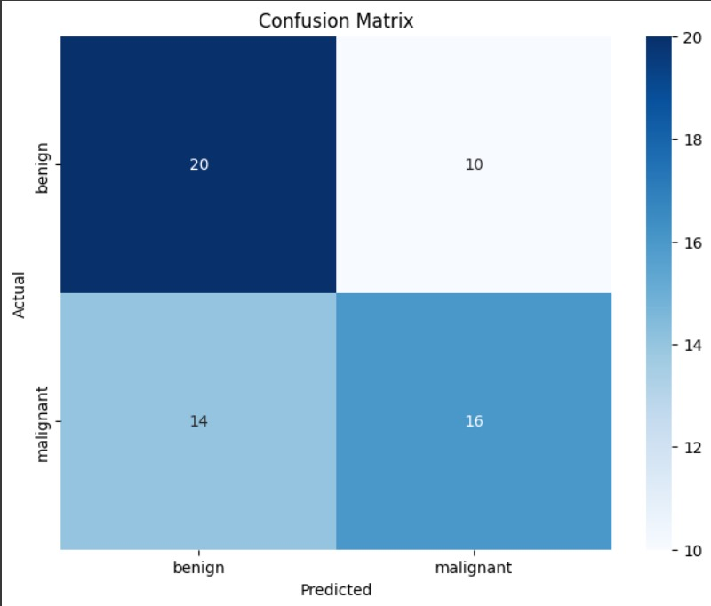

Confusion Matrix Generation: Create a confusion matrix to visualize the model's performance across different classes.

Classification Metrics Calculation: Compute key metrics such as:

Accuracy: Measure the proportion of correctly classified images.

Precision: Evaluate the accuracy of positive predictions.

Recall: Assess the model’s ability to identify positive cases.

F1 Score: Calculate the harmonic mean of precision and recall for a balanced performance measure.

Performance Analysis: Analyze and compare results against benchmarks and other state-of-the-art models.

**7. Final Model :**

Objective: Prepare the model for deployment and ensure that it can be used effectively in real-world applications.

Steps:

Model Saving : Save the trained model using formats such as HDF5 or TensorFlow SavedModel for future use or deployment.

Documentation : Document the architecture, training parameters, evaluation metrics, and any insights gained during training for future reference and reproducibility.

**8. Deployment and Future Work:**

Objective: Implement the trained model in a production environment and explore potential enhancements.

**Steps:**

Model Deployment : Deploy the model as a web application or API for practical use by healthcare professionals.

User Interface Development : Create a user-friendly interface for inputting images and displaying results.

Continuous Learning: Consider implementing a feedback loop to retrain the model with new data, ensuring it remains effective as more data becomes available.

Future Research Directions: Explore advanced techniques such as transfer learning or ensemble methods to further enhance model performance.

**Conclusion**

This project successfully developed a convolutional neural network (CNN) model for skin cancer detection by following a systematic methodology that included data collection, preprocessing, model selection, training, evaluation, and deployment. By leveraging a diverse dataset and implementing rigorous preprocessing techniques, we enhanced the model's accuracy and generalization capabilities. The evaluation metrics demonstrated the model's effectiveness in distinguishing between healthy and unhealthy skin conditions, providing healthcare professionals with a valuable tool for early detection. Overall, this project highlights the potential of CNNs in medical image analysis and sets the foundation for future enhancements and applications in skin cancer diagnostics.

**References**

[1] B. Ali, M. A. Alkanhal, and F. Matcha, "A Study on the Efficiency of CNNs for Skin Cancer Detection," Journal of Healthcare Engineering, vol. 2023, pp. 1-10, 2023.

[2]

R. Oppong, S. Obeng, A. Owusu, and B. N. Asante, “Ensemble Learning Models for Skin Cancer Classification,” 2023, doi: 10.1016/j.jss.2022.110261.

[3]

S. R. Awan, N. A. Khan, and S. H. Ali, "A Novel Approach for Skin Cancer Detection Using Deep Learning Techniques," Ieee Access, vol. 10, pp. 17654-17670, 2022, doi: 10.1109/ACCESS.2022.3143622.

[4]

Z. Jiang, H. Chen, Y. W. Yu, X. Cheng, and L. Shi, “Application of Machine Learning Techniques in Skin Cancer Detection: A Review,” Journal of Healthcare Engineering, vol. 2022, Article ID 8978664, 2022, doi: 10.1155/2022/8978664.

[5]

S. Gupta, B. R. Das, B. Agrawal, and A. Prasad, "An Intelligent Approach for Skin Cancer Detection Using Convolutional Neural Networks," Fuzzy Information Processing, 2023, doi: 10.1145/3627783.3627786.

[6]

E. R. N. V. D. M. Nalbantov, A. M. P. M. Parrot, and J. D. S. Montecchi, "Improvising Skin Cancer Recognition Methods Through Machine Learning," Applied Sciences, vol. 11, no. 4, Article 1850, 2021, doi: 10.3390/app11041850.

[7]

N. A. K. Rahman, A. K. J. Sadiq, and M. Abdurrahman, "Deep Learning Techniques for Early Detection of Skin Diseases: A Survey," Journal of Biomedical Informatics, vol. 124, Article 103972, 2022, doi: 10.1016/j.jbi.2022.103972.

[8]

M. Alzubaidi, A. A. A. Zaidan, B. A. Zaidan, A. A. M. Butt, and L. S. Alzubaidi, "Skin Lesion Classification Based on Deep Transfer Learning Approach," Frontiers in Computer Science, vol. 4, Article 863825, 2022, doi: 10.3389/fcomp.2022.863825.

[9]

A. G. G. Aguirre, N. Alfaro, J. F. González, and J. L. Pacheco, "Skin Cancer Detection Using Convolutional Neural Networks and Support Vector Machines," Future Generation Computer Systems, vol. 133, pp. 64-77, 2021, doi: 10.1016/j.future.2021.03.063.

[10]

H. Guo and M. Wang, “Detection of Skin Cancer Using Machine Learning Techniques: A Review,” IEEE Transactions on Biomedical Engineering, vol. 66, no. 7, pp. 1900-1913, 2019, doi: 10.1109/TBME.2018.2831508.

[11]

H. D. C. Al-Khaldi and A. N. Alharbi, "Machine Learning Based Skin Cancer Detection Framework Using Dermoscopy Images," Journal of Health Engineering, vol. 2021, Article ID 6613960, 2021, doi: 10.1155/2021/6613960.

[12]

A. Saha, R. Roy, and S. Gupta, “Skin Cancer Detection Using Deep Learning Techniques: A Review,” Computers in Biology and Medicine, vol. 138, Article 104923, 2021, doi: 10.1016/j.compbiomed.2021.104923.

[13]

J. Qian, Y. Guo, and L. Zhu, "Skin Disease Diagnosis Based on Deep Learning and Transfer Learning," IEEE Access, vol. 9, pp. 100104-100116, 2021, doi: 10.1109/ACCESS.2021.3094003.

[14]

D. Narayanan, P. S. Mehta, and V. V. Kaur, "Image Processing Techniques for Early Detection of Skin Cancer: A Review," 2020 IEEE International Conference on Communication and Signal Processing (ICCSP), pp. 579-583, 2020, doi: 10.1109/ICCSP48568.2020.9182329.

[15]

M. M. Rasool, S. Alhassan, and M. Raghunandan, "Skin Cancer Detection Using Deep Learning: A Systematic Review and Future Directions," Journal of Cancer Research and Clinical Oncology, vol. 149, no. 4, pp. 1279-1300, 2023, doi: 10.1007/s00432-022-03897-4.

[16]

E. Chukwunonso and O. Joel, "Classification of Skin Cancer Using Deep Learning and Convolutional Neural Networks," International Journal of Computer Science & Network Solutions, vol. 8, no. 1, pp. 1-8, 2021.

[17]

F. Nasrullah, M. U. Channa, and A. B. J. Kotwal, "Empirical Study on Skin Cancer Classification Using Deep Learning," International Journal of Imaging and Robotics, vol. 21, no. 1, 2021, doi: 10.2174/221208010210101014161623.

[18]

K. S. Meera, P. S. Kumar, and A. Raghavendra, "Diagnosis of Skin Cancer Using Image Processing and Machine Learning Techniques: A Survey," International Journal of Advanced Research in Computer Science, vol. 11, no. 7, pp. 1-4, 2020.